Integration of Ollama in BankBot AI Chatbot

1. Introduction
Ollama is a local Large Language Model (LLM) runtime that enables developers to run advanced AI models directly on their own machine without depending on cloud services.
In the BankBot AI project, Ollama provides intelligent natural-language responses when user queries do not match any predefined FAQ.
This integration allows:
Offline AI responses
Faster processing (no external API calls)
Lower cost compared to cloud LLM APIs
Full data privacy (queries remain on the user system)

2. What is Ollama?
Ollama is an open-source tool that allows running LLMs(Large Language Models)
such as:
Mistral
Llama2
Gemma
NeuralChat
TinyLlama
Custom GGUF models

Key Features
- Runs locally (no internet needed)
- Easy REST API (localhost:11434)
- Supports multiple models
- Fast inference with GPU acceleration
- Secure and customizable

3. Why Use Ollama in BankBot AI?
Requirement | How Ollama Helps
Need AI responses for non-FAQ questions | LLM processes dynamic queries
Offline chatbot | Ollama works locally
Faster response time | No network latency
Privacy and security | Data stays local
Cost efficient | No API billing
Thus, Ollama is the intelligent fallback engine when FAQ matching fails.

4. Installation of Ollama

Step 1 — Install Ollama
Download from:
🔗 https://ollama.com/download

Step 2 — Pull the required model
In your terminal:
ollama pull mistral
The project uses Mistral because it is:
- Lightweight
- Fast
- High quality
- Good for banking FAQ response patterns

Step 3 — Start Local LLM Server
ollama serve
This enables the API endpoint:
http://localhost:11434/api/generate

5. How BankBot Integrates With Ollama

5.1 When is Ollama Used?
Ollama is only used when:
The user message does not match FAQ keywords
The query requires natural language understanding
The bot needs to generate a customized response
For example:
❌ FAQ found → return predefined text
✔ No FAQ found → call Ollama

6. Code Implementation of Ollama Integration

6.1 The Ollama API Function
def ask_ollama(prompt: str, model: str = "mistral") -> str:
try:
resp = requests.post(
"http://localhost:11434/api/generate",
json={"model": model, "prompt": prompt},
timeout=120,
)
return resp.json().get("response", "⚠️ No response from Ollama.")
except Exception as e:
return f"⚠️ Ollama error: {e}"

What this function does?
- Sends user prompt to Ollama API
- Ollama runs the model locally
- Returns generated text to Streamlit
If anything goes wrong (API down, timeout), the function gives a readable error.

6.2 The Ollama Quick FAQ Topics:
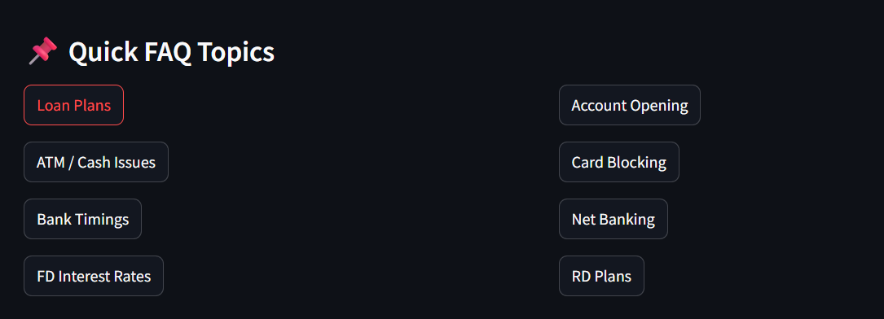

7. How Prompts Are Created for Ollama
When FAQ doesn't answer the question, this prompt is used:
prompt = f"You are BankBot. Answer clearly:\n{user_text}"
reply = ask_ollama(prompt)

Prompt design guidelines used:
- Keep it short → faster response
- Make the bot follow banking assistant role
- Encourage clear responses

System Architecture
1.User Interface Layer
Built using Streamlit
Contains chat window, FAQ buttons, and sidebar history
2.Application Logic Layer
Checks FAQ matches
Manages chat history
Chooses between FAQ and AI response
3.AI Engine (Ollama Mistral Model)
Handles natural language queries
Runs locally (offline)
4.Session Storage Layer
Saves conversations
Maintains multiple chats

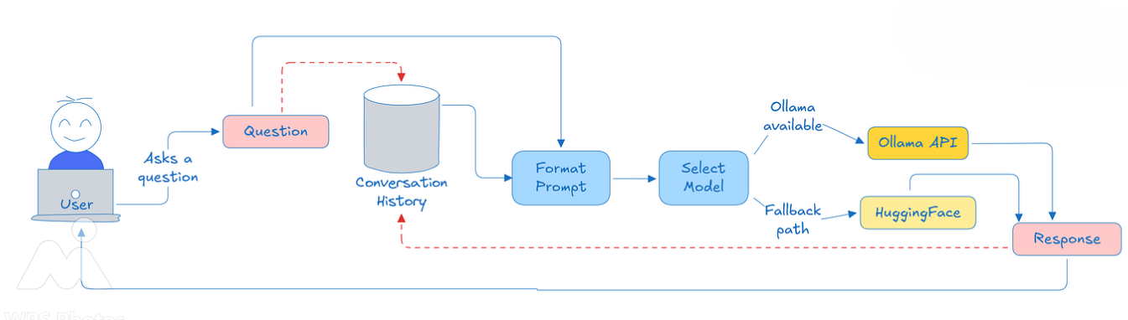

Flowchart
START
│
▼
User Opens Chatbot
│
▼
Show Welcome Message + FAQ Buttons
│
▼
User Inputs Query
│
▼
Is Query an FAQ match?
│ \
YES ▼ ▼ NO
Show predefined Send prompt to Ollama
FAQ answer get AI Response
│ |
▼ ▼
Add answer to chat history
│
▼
Display Updated Chat
│
▼
WAIT FOR NEXT INPUT

10. Integration with Streamlit Workflow

Step-by-step process:
- User sends a message
- System checks for FAQ match
- If no match, format a prompt
- Call ask_ollama(prompt)
- Receive AI-generated answer
- Store it in session_state
- Rerun Streamlit UI

11. How to Run the Project

Step 1: Install dependencies
pip install streamlit requests

Step 2: Install Ollama
Download from: https://ollama.com
Then pull model:
ollama pull mistral

Step 3: Run Streamlit
streamlit run app.py

12. Benefits of Ollama Integration

1. Offline AI chatbot
No need for OpenAI, Google, or cloud services.

2. Faster than cloud APIs
Zero network delay → almost instant replies.

3. Privacy-friendly
All messages remain on your computer.

4. Cost-free
No API billing.

5. Supports custom models
You can train your own banking model (future upgrade).

13. Future Enhancements With Ollama
You can expand integration:
Fine-trained model for banking FAQs
Multi-model switching (Mistral, Llama, Gemma)
Conversation memory using LLM context
Vector database integration
Voice-based banking assistant

14. Conclusion
Integrating Ollama into BankBot AI transforms the system from a simple FAQ bot into a powerful AI-driven assistant. Ollama enhances BankBot with:
Offline conversational capabilities
Secure local processing
High-quality contextual responses

